Communications Toolkit: Promoting the Partnerships for Sustainable Cities Second Meeting

Dear Partners,

We are excited to welcome you to the Partnerships for Sustainable Cities programme’s second and final global meeting in Barcelona from 12-14 March 2024. As a valued partner, we invite you to help us spread the word about this important event to your network. We created this communications toolkit to help you share the news.

Social media

Hashtags

When posting about the meeting - and the programme - we encourage you to always include the following two hashtags:

#Partners4SustainableCities
#SustainableCities

Template social media posts

1.
🌟We're excited to announce {NAME OF YOUR CITY} will be at the second global meeting of the Partnerships for #SustainableCities initiative in Barcelona from 12-14 March!

Keep an eye on our account to learn more about this initiative supported by @EU_Partnerships

2.
🏙️The Partnerships for Sustainable Cities initiative is a key component of our efforts to create a more livable and sustainable [NAME OF YOUR CITY]

We look forward to collaborating with our 🌍partners in Barcelona! Let's shape the future of #UrbanDevelopment together.

#Partners4SustainableCities

Social media best practices

- Share any news, updates, or highlights from the event on your social media channels during and after the meeting
- Repost from accounts of other municipalities joining the meeting
- Highlight any partnerships or projects you are participating in through the initiative and how they have contributed to your municipality
- Tag relevant stakeholders, partners, and organisations in your posts to broaden the reach and encourage engagement

Image

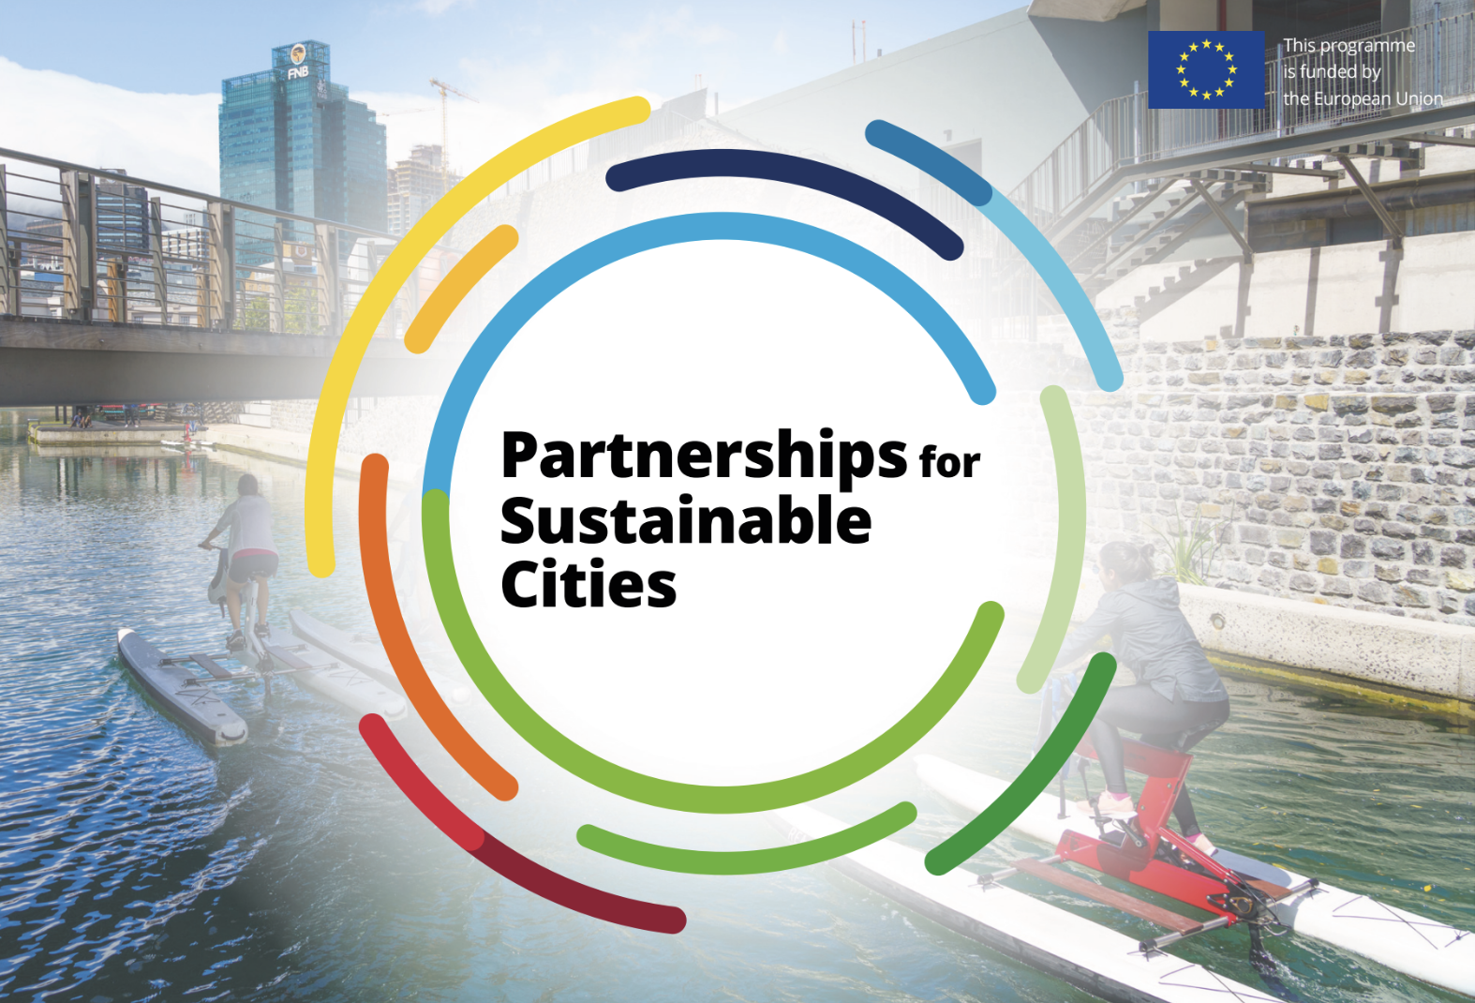
We invite you to include this image in your social media posts - tagging relevant accounts such as DG INTPA (@EU_Partnerships), ECDPM, (@ECDPM) and other municipalities. This image was sent to you in the same email in which the toolkit was shared. Should you choose to post during the meeting, please include pictures you take of the sessions, group photos, etc.

Videos and Platform

There will be a Partnerships for Sustainable Cities programme video that will be shot during the event. Once this is publicly available, we will send you an email, inviting you to download and use it in your promotional activities afterwards.

You can still access the previous videos from our website or from the European Commission’s website.

You can find more information about all 57 projects on the Partnerships for Sustainable Cities platform: https://partnerships4sustainablecities.eu/. If you still haven’t done it, upload good pictures to illustrate your project.

Press Release

We produced a press release for you to use in your own dissemination activities. You can access it here.

Thank you for your support in promoting the Partnerships for Sustainable Cities programme and the second global meeting.

We look forward to working together to achieve more livable, sustainable, and resilient cities.

Best regards,

The Coordination Team

